# DATABASE SYSTEM PRACTICUM REPORT

# MODULE 5

**DML**



**CREATED BY :**

**KURNIAWAN BAGASKARA**

**L200214253**

# INFORMATICS STUDY PROGRAM

**FACULTY OF COMMUNICATION AND INFORMATION SCIENCE MUHAMMADIYAH SURAKARTA UNIVERSITY**

1. Table Transaksi:

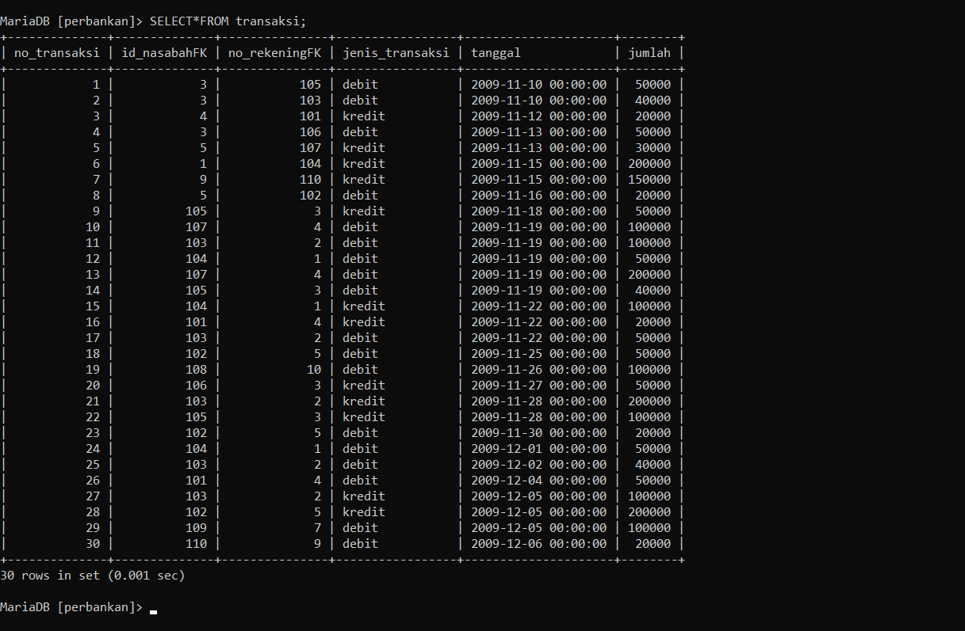

1. Update :
2. 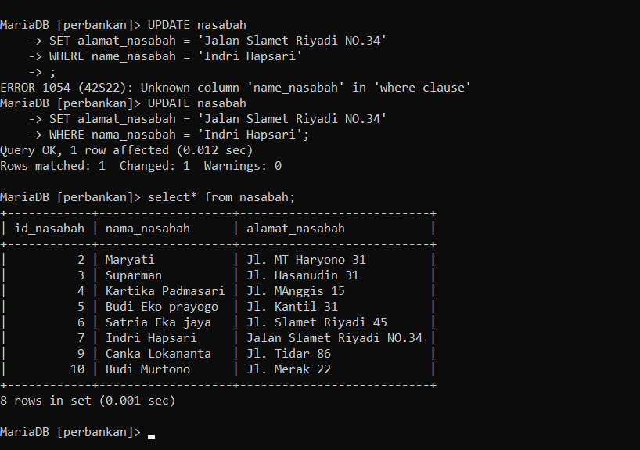
3. 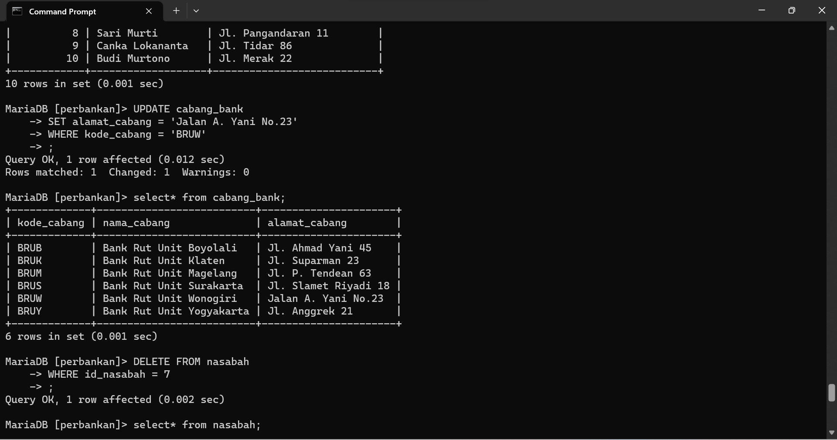
4. Delete:
5. 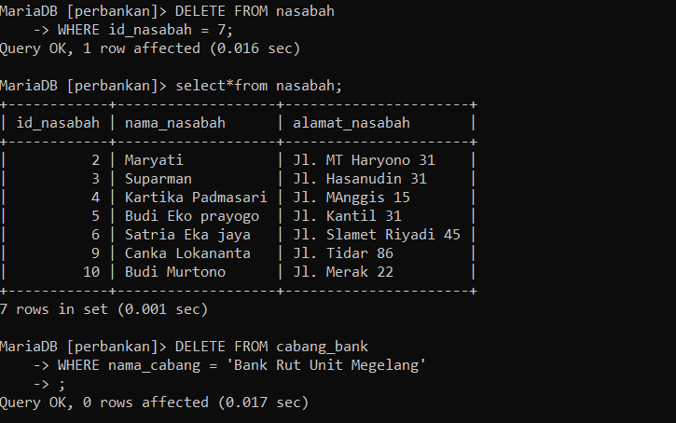
6. 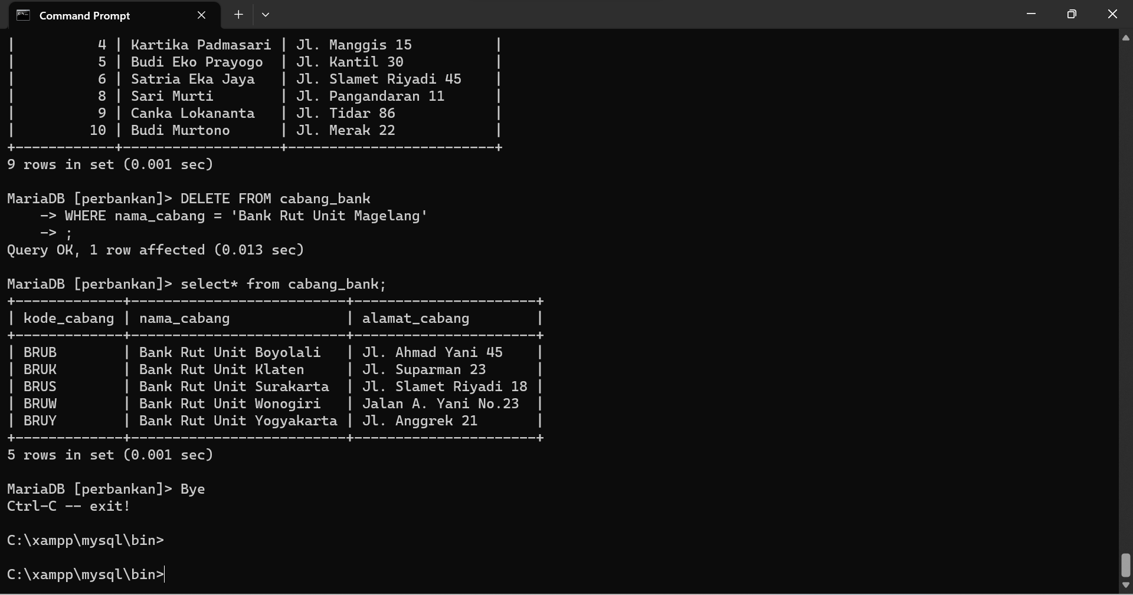

**TASK!**

**Enter several records into each table in the database that you created in module 4. Print out the results of implementing the design and analyze the results. (Each 10 records for the master table and 20 records for the transaction table).**

Nasabah:

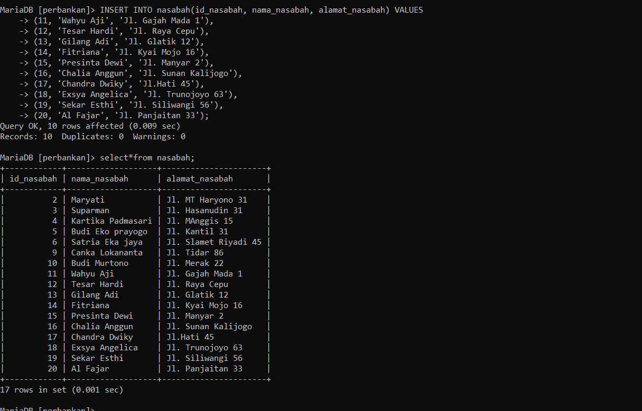

Cabang_Bank:

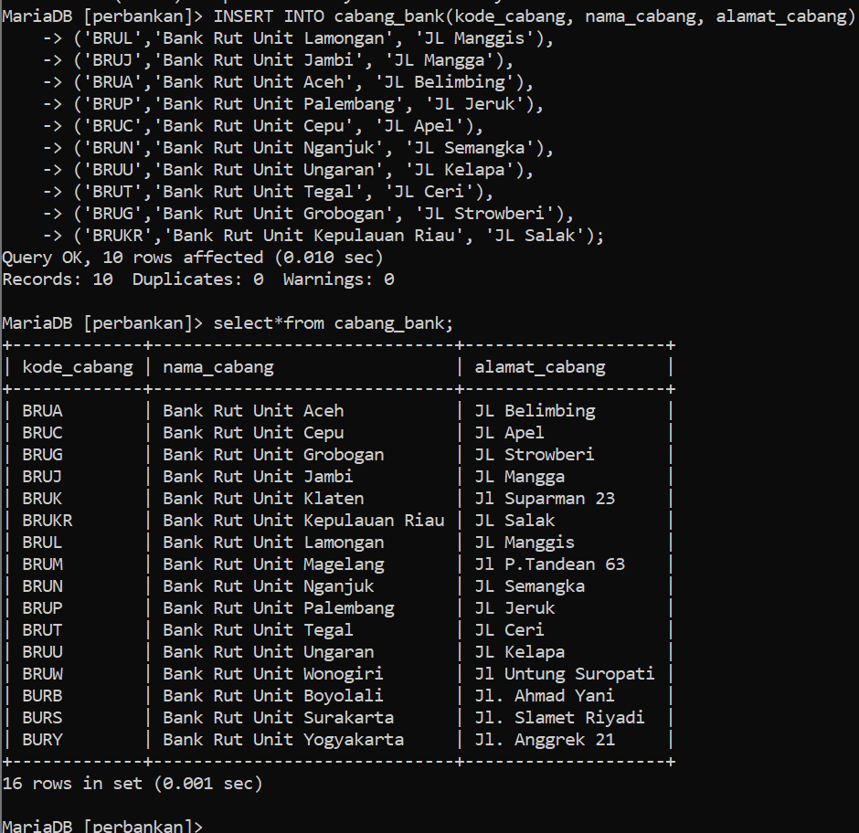

Rekening :

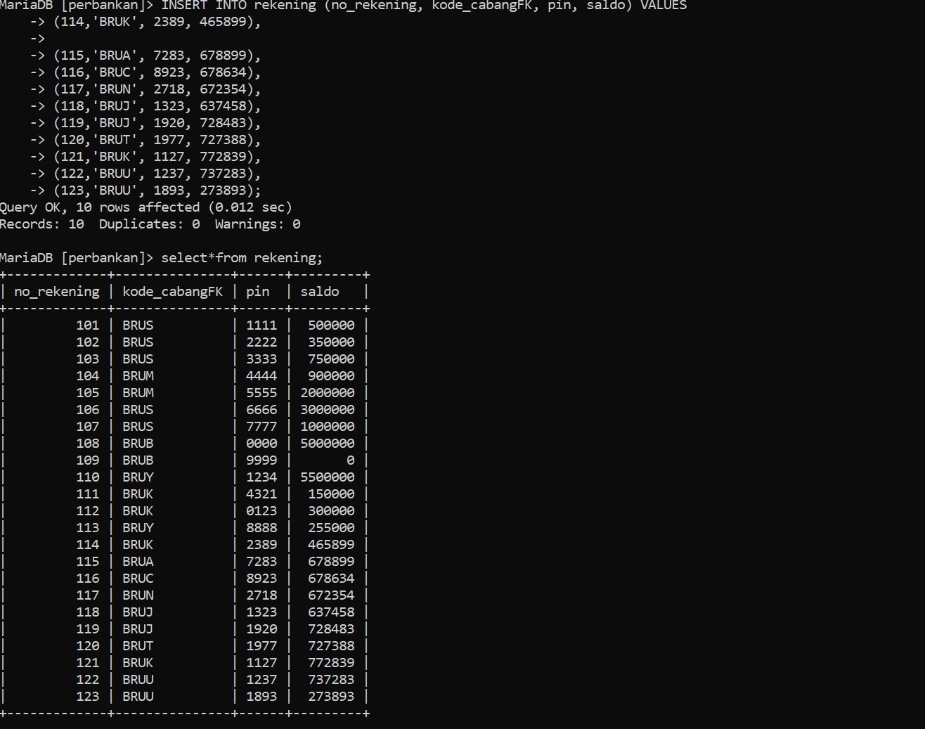

Nasabah_has_rekening:

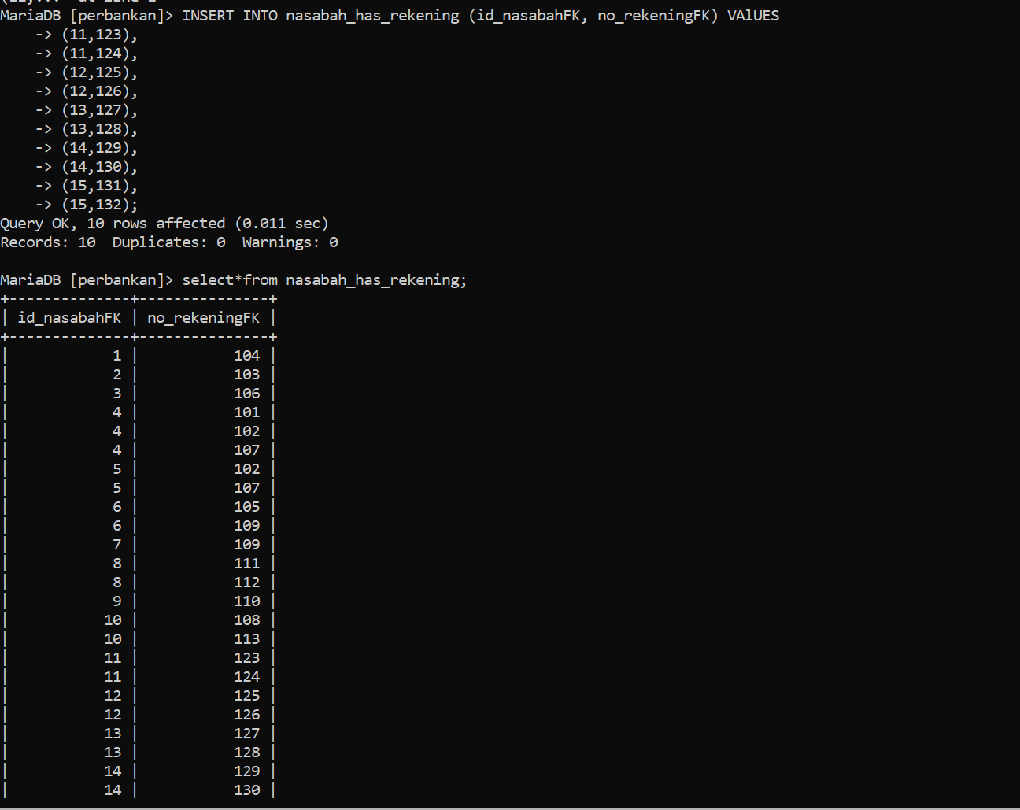

Transaksi :



